DATABASE MANAGEMENT — SQL&PL/SQL

SESSION – 2

1.Open MySQL Workbench or CLI and write a CREATE TABLE statement to create a table called 'restaurants' with columns: id (INT, primary key, auto-increment), name (VARCHAR(100)), location (VARCHAR(100)), and rating (DECIMAL(2,1)).
ANS: CREATE TABLE restaurants (
id INT PRIMARY KEY AUTO_INCREMENT,
name VARCHAR(100),
location VARCHAR(100),
rating DECIMAL(2,1)
);
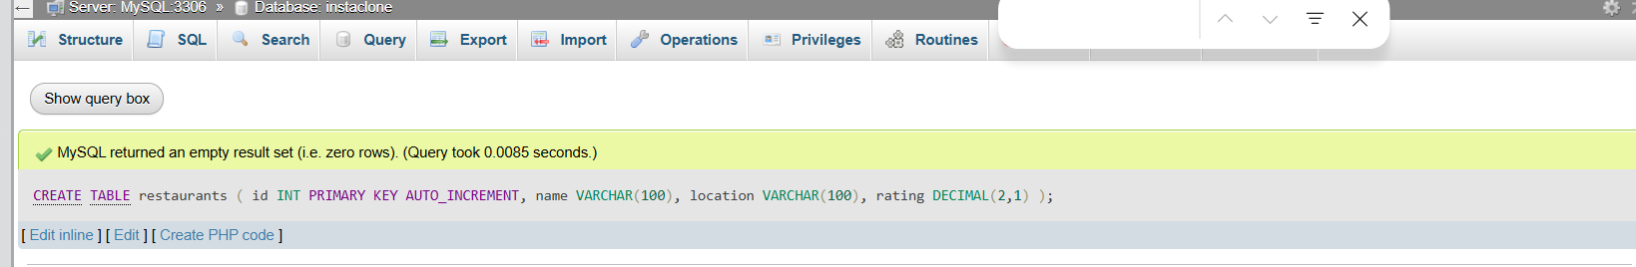

2.Use the ALTER TABLE command in MySQL to add a new column 'average_cost' (INT) to your 'restaurants' table.<br><br><em><strong>Hint:</strong> Remember to specify the data type when adding a new column.</em>
ANS:
ALTER TABLE restaurants
ADD COLUMN average_cost INT;
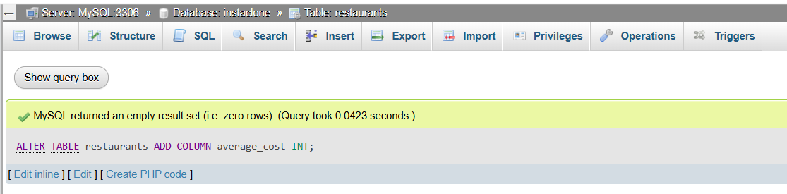

3.Write a SQL statement to DROP the 'restaurants' table you created earlier. Double-check your command before running it to avoid accidental data loss.
ANS:
DROP TABLE restaurants;
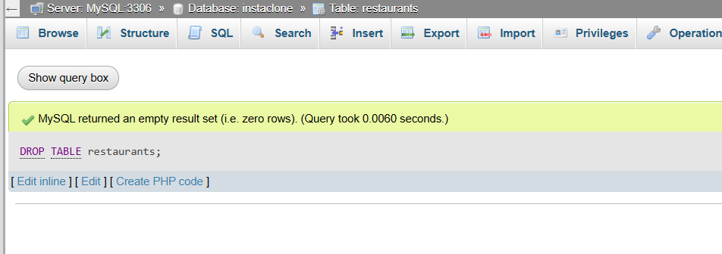

4.Create a new table called 'playlists' for a music app like Spotify, with columns: playlist_id (INT, primary key, auto-increment), title (VARCHAR(50)), created_by (VARCHAR(50)), and created_at (DATE).
ANS: CREATE TABLE playlists (
playlist_id INT PRIMARY KEY AUTO_INCREMENT,
title VARCHAR(50),
created_by VARCHAR(50),
created_at DATE
);

